Applied Maths Higher Level 2021

2021 Question 1 (a)
A ball is thrown vertically downwards from the top of a building of height h m.
The ball passes the top half of the building in 1.2 s and takes a further 0.8 s to reach the bottom of the building.

Find
- the value of h
- the speed of the ball at the bottom of the building.

2021 Question 1 (b)
Car C, moving with uniform acceleration f passes a point P with speed u (> 0).

Two seconds later car D, moving in the same direction with uniform acceleration 2f passes P with speed $\frac{6}{5}$ u.
C and D pass a point Q together.
The speeds of C and D at Q are 6.5 m s^{–1} and 9 m s^{–1} respectively.
- Show that C travels from P to Q in ($\frac{3}{2f}$+ 5) seconds.
- Find the value of f.

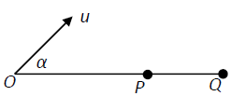
2021 Question 3 (a)
A particle is projected from a point O with speed u m s^{–1} at an angle α to the horizontal.
- Show that the range of the particle is $\frac{u^{2}\sin{2α}}{g}$,
and that the maximum range ∣OQ∣ is $\frac{u^{2}}{g}$ .

- If the angle of projection is increased to 60° the particle strikes the horizontal plane at P.
Find the distance ∣PQ∣ in terms of u.

2021 Question 4 (a)
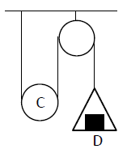
The diagram shows a light inextensible string having one end fixed, passing under a smooth movable pulley C of mass km kg and then over a fixed smooth pulley.
The other end of the string is attached to a light scale pan.
A bock D of mass m kg is placed symmetrically on the centre of the scale pan.
The system is released from rest. The scale pan moves upwards.
- Show that k > 2.
- Find, in terms of k and m, the tension in the string.
- Find, in terms of k and m, the reaction between D and the scale pan.

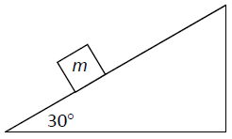
2021 Question 4 (b)
A smooth wedge of mass 4m and slope 30° rests on a smooth horizontal surface.
A particle of mass m is placed on the smooth inclined face of the wedge and is released from rest.
A horizontal force F is applied to the wedge to keep it from moving.
- Show, on separate diagrams, the forces acting on the wedge and on the particle.
- Find F in terms of m.
{Part (iii) is no longer on the course so is not included}

2021 Question 5 (a)
A smooth sphere A of mass 4m, moving with speed u on a smooth horizontal table collides directly with a smooth sphere B of mass m, moving in the opposite direction with speed u.
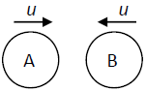
The coefficient of restitution between A and B is e.

- Find the speed, in terms of u and e, of each sphere after the collision.

- The magnitude of the impulse on B due to the collision is 𝑇.
Show that $\frac{8mu}{5}≤T≤\frac{16mu}{5}$

2021 Question 5 (b)
A smooth sphere P has mass 2m and speed u. It collides obliquely with a smooth sphere Q of mass m which is moving with speed ku, as shown in the diagram.

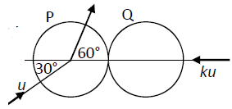
Before the collision, the direction of P makes an angle of 30° to the line of centres. After the collision, the direction of P makes an angle of 60° to the line of centres.
The coefficient of restitution between the spheres is 𝑒.
- Show that $k= \frac{\sqrt{3}(1-e)}{2(1+e)}$
- Find the speed of Q immediately after the collision.

2021 Question 6 (b)
A smooth slide EFG is in the shape of two arcs, EF and FG, each of radius r.
The centre O of arc FG is vertically below F as shown in the diagram.
Point E is at a height $\frac{r}{5}$ above point F.
A child starts from rest at E, moves along the slide past the point F and loses contact with the slide at point H.
OH makes an angle 𝜃 with the vertical.
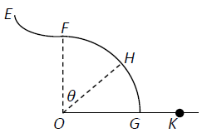
- Find the value of 𝜃.

- The child lands in a sandpit at point K.
Find, in terms of r, the speed of the child at K.

2021 Question 10 (a)
A car of mass 1200 kg starts from rest and travels along a straight horizontal road.
The engine of the car exerts a constant power of 3000 W.
If there is no resistance to the motion of the car, find
- the speed of the car after 3 minutes
- the average speed of the car during this time.

2021 Question 10 (b)
𝑃, the population of insects in a region, grows at a rate that is proportional to the current population.

$$\frac{dP}{dt}= kP$$

where 𝑘 is a positive constant. In the absence of any outside factors the population will triple in 15 days.

- Find the value of 𝑘.

- A scientist begins to remove 10 insects from the population each day.
If there are initially 120 insects in the region the population will not survive.
After how many days will the population die out?

